# Exception Handling in Blue Prism

Recover and Resume are the stages which are been used for exception handling in Blue Prism

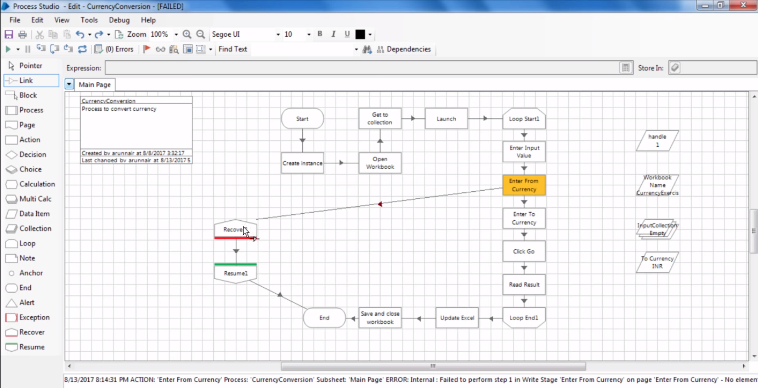

Recover Stage does not take any incoming path as given in above screen shot we are trying to connect action stage to recover stage but it did not allow us to do so.

As Recover stage works as a powerful magnet so if there is any exception in the application then it automatically attracts that and the program now goes through Resume Stage and END.

Now let us capture exception and store that in a data item

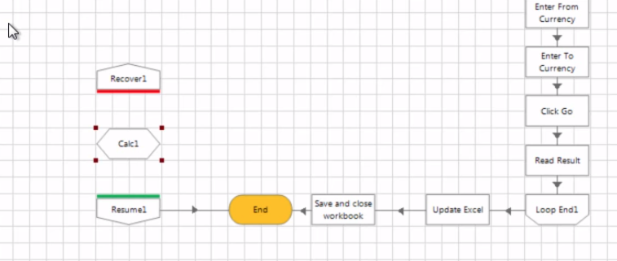

We put a calculate stage between recover and resume stage and open its properties.

There is a section called exception in there which has following expressions –

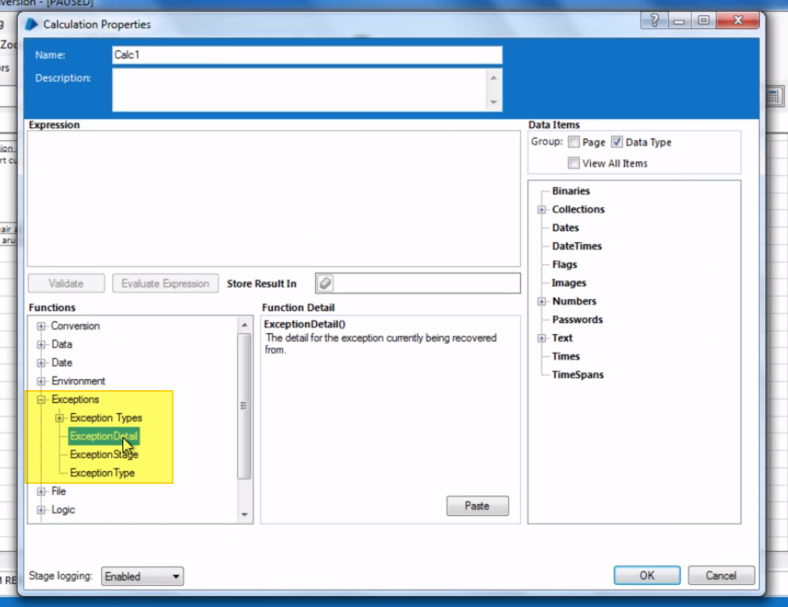

Let us click on Exception Details and it load a section next to it. We do not need to type any expression in there else just click on paste button and give a data item to store result in there.

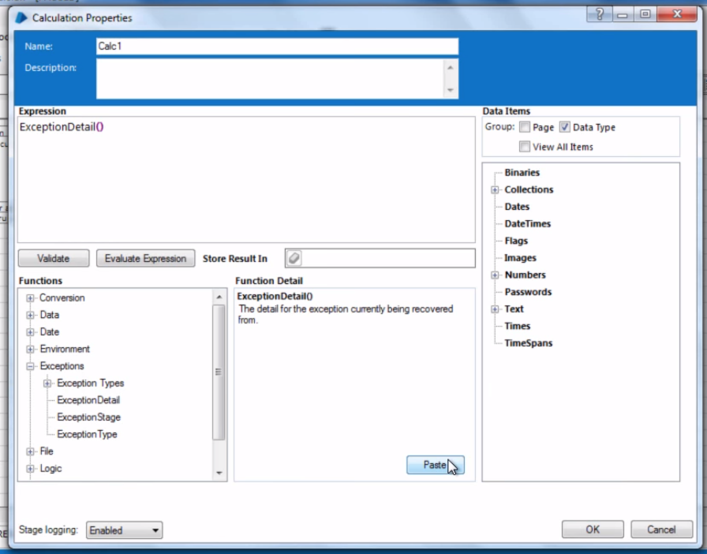

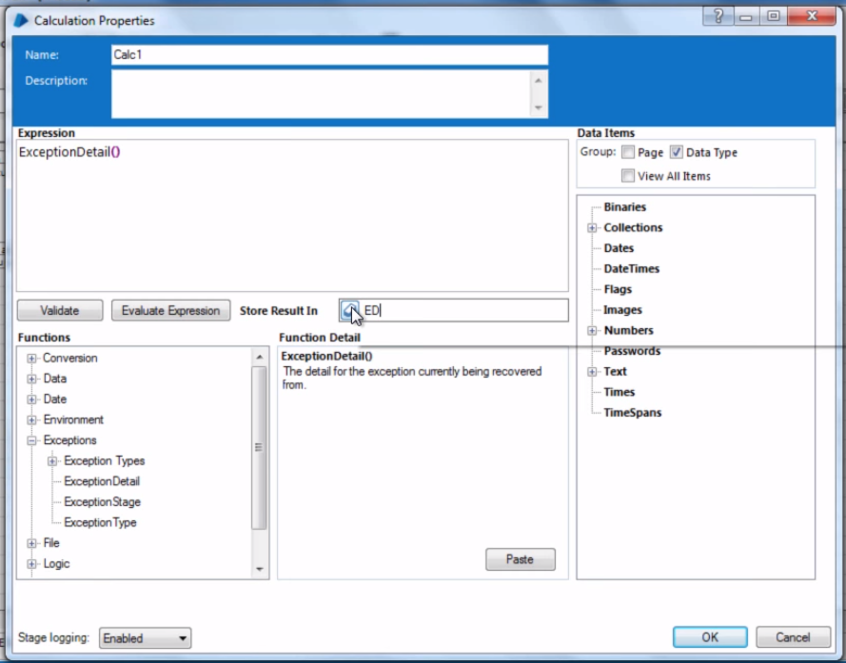

Note: If a calculate stage is placed between End and Resume stage then it will not capture the exception details as once the resume stage is passed then all details about the exception is get difused.

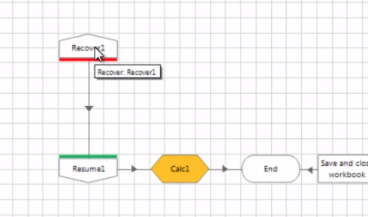

If we do something like this then it will end up as an endless loop and execution will go from calc stage to recover and resume and again recover and resume and calc and recover vice versa.

As when it comes to calc stage then it ask for exception and it does not get that information hence it throws an exception and execution goes to recover again and on and on.

Now let’s if we want to give a custom message instead of the default message in case if any errors comes out, then in that case,

Let’s open a Object studio and open an action and apply exception stage like below-

Exception stage allows us to give custom message for Exception Type.

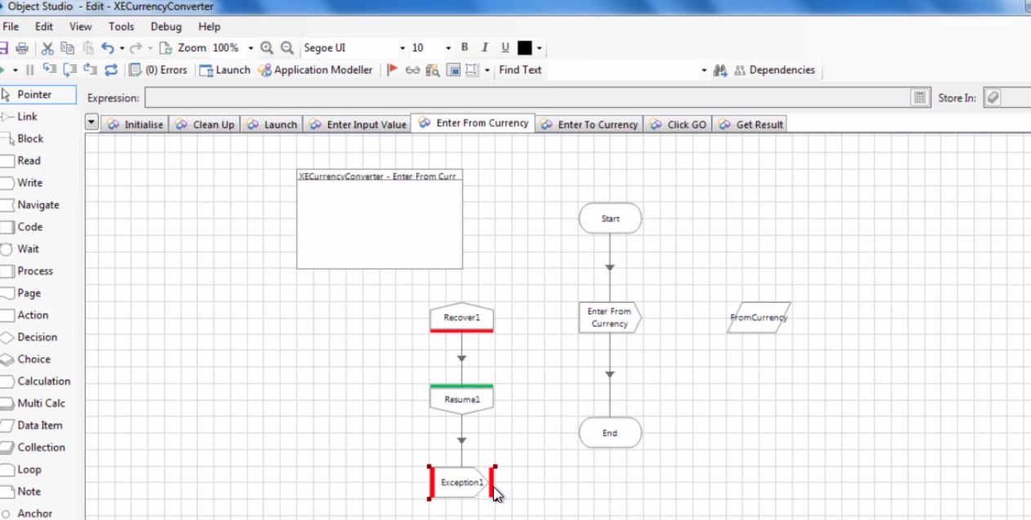

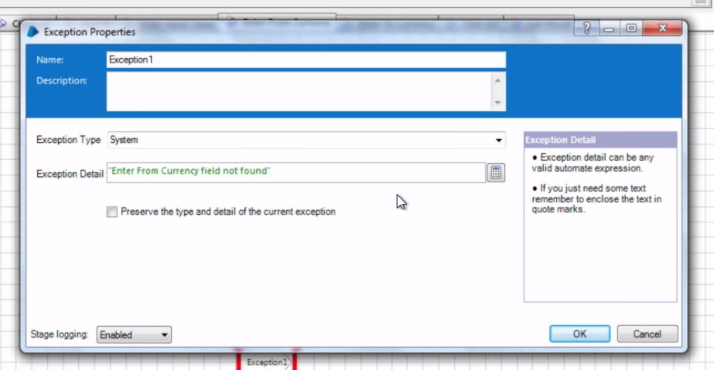

But again in this case this will result in endless loop as exception stage will throw an exception after getting exception from recover and resume stage and recover stage will again capture that exception then how to get rid from this problem.

Answer is, using block stage. We use block stage and as shown in below figure. Block restrict recover to work only for the exception comes from the stages those are in block only.

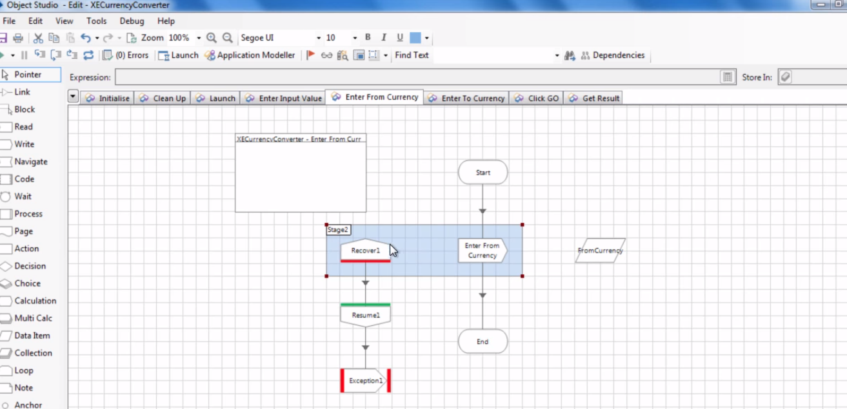

Now if user create additional recover and resume stages in the process then those will be redundant and process will only follow the very first defined recover and resume stages only.

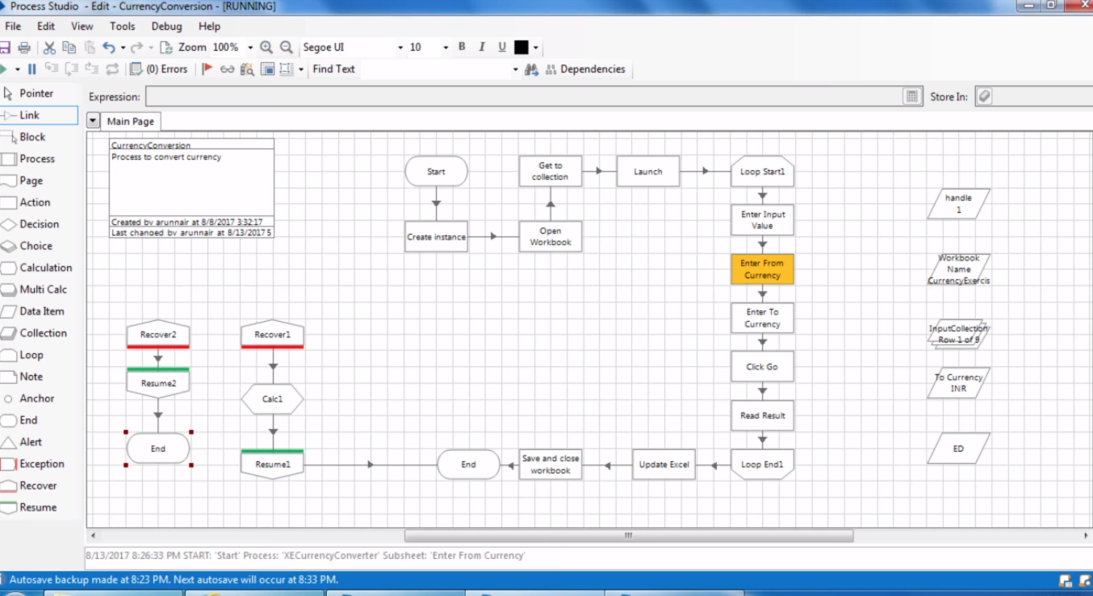

So in the example above the only first defined recover and resume will be used which is connected with calc stage.

# Exception Bubbling

Let take an example –

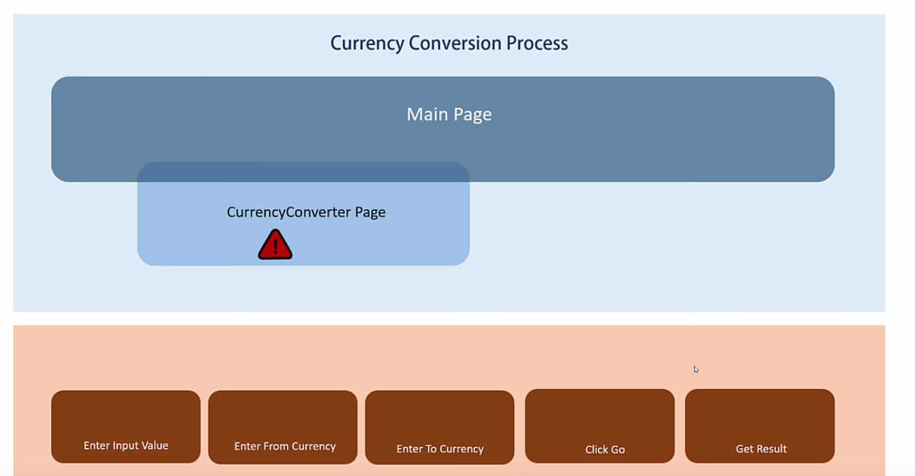

We have an main page and refer to another page currently converter page. And down below it are the actions.

Now let’s suppose if exception occur at actions is not being handled at actions page in object studio then execution will come one layer up and transfer that exception to the one layer up which is currenyConvertor page in this case. If the exception is not being handled there as well then it will again come one layer up and transfer that exception to the main page. Now if main page has exception handled using recover and resume stages then it will follow that path and process will end gracefully in that case else it will throw an error.

And this process of transferring error/exception one layer up is called exception bubbling.